(Approx. 1969 words)
Intro to IP Addresses and Port Numbers
The foundation for any app that communicates with other computers is an IP address and port number. Learn how that works.
By John Krout, Presenter and Newsletter Contributor
Potomac Area Technology and Computer Society
www.patacs.org
Introduction
Much of what we all do with computers is based on communication with other computers through a digital network. Email, web browsing and streaming video are three of many examples.
All that communication is based on Internet Protocol (IP) addresses and a related concept called port numbers. This article will explain those concepts and how the device which provides your home Wi-Fi, called a router, plays a critical role in digital network communication.
Every computer, smartphone, and tablet has an IP address, at least when connected to a network. The purpose of the IP address is just like your home address, often called a street address. For example, delivery services such as the US Postal Service, Federal Express (FedEx), United Parcel Service (UPS), and many others can deliver mail and packages because packages are labeled with your street address. Likewise, the IP address assigned to your computer, smartphone, and tablet serves the same purpose: digital info for your device is delivered fast and accurately because it is labeled with your device's IP address.
One difference is that your device, a computer, smartphone, or tablet, has to ask for digital info. You use an email application or a Web page to request email, and then the new emails are delivered to your device from a computer acting as an email server. This is an example of client-server computing, in which your device's software is called a client, and the email server is called a server. You ask to see the new incoming email, and the server delivers. You use your application or Web browser to compose and send an email, and the computer forwards it to the email server, which then sends it to the destination domain specified in your email. In all client-server computing scenarios, the client application does part of the work, and the server application does another part of the work.
Domain Name Service (DNS)
Behind the scenes, when you receive or send an email, or you ask to see a web page, two things happen. First, your request for digital info includes the IP address of the device you are using.
Another server, called a Domain Name Server (DNS), helps in a big way: it converts the domain portion of the recipient address, such as @yahoo.com or @gmail.com, or @nasa.gov, to an equivalent IP address. Using that IP address, other computers can relay your request to the destination and send the reply to your device. You need to know only the name, not the IP address, of the server you contact. Over time, the destination IP address for a familiar domain name might change, but the DNS stays up to date and allows you to use a familiar domain name instead of a changed IP address.
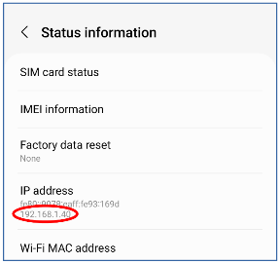
What does an IP address look like?
Inside your computer, smartphone, and tablet, all data is numbers. A byte is a number, a group of 8 bits with a collective value from 0 to 255. Combining bytes in creative ways lets us write emails, display web pages, and so forth.
Likewise, an IP address is a number composed of four bytes. An IP address is expressed like this: 192.168.1.42. Each byte in the address is separated from the next by a period.
How to See your device IP address
Illustration 1
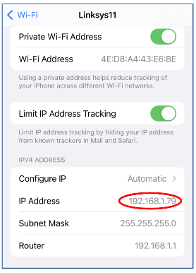
Android 12: Open the Settings app, choose About phone, and then choose Status Information. Look under the heading IP address. You can see an example of that screen captured on a Samsung Galaxy S10 running Android 12 in illustration 1, with the IP address circled.
iOS 15 (Apple): Open the Settings app and choose Wi-Fi. You will see your Wi-Fi network name below the Wi-Fi switch, with some gadgets to the right. Tap the info button (the letter i in a circle) to the right of the name of your Wi-Fi network. A new screen appears. Scroll down and find the IPv4 address heading. Below that, you will see both your device's IP address and the internal IP address of your router. Finally, you can see an example captured from an iPhone X and iOS 15 in illustration 2, with the IP address circled.
Illustration 2
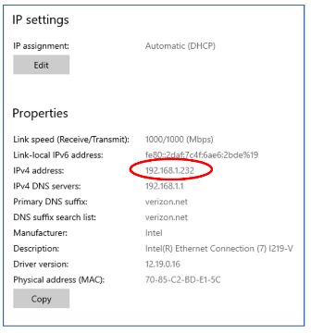
Windows 10: Open the Settings application, choose Network & Internet, and click the Properties button in the right-hand pane. A new screen appears; scroll to the bottom and find the IPv4 address. You can see an example in illustration 3, circling the IP address.
Port Numbers
As you know from experience, your device can communicate with many other computers simultaneously. For instance, your device can run an email client application, a web browser, and a video streaming application concurrently.
Your device uses a second concept called port numbers to properly deliver incoming digital info to the correct application on your device.
Illustration 3
Ports are analogous to apartments within an apartment house. Each apartment has its own apartment number. Physical deliveries are directed to the correct apartment by being labeled with the correct apartment house address and apartment number.
Think of your device's applications as apartments. Each uses a port devoted to the purpose of the application. The ports are numbered, the number range is 0 through 65535, so there are 65,536 ports.
Some of the port numbers are, by internet convention, devoted to specific purposes. For example, some port numbers are devoted to email, and some are for web browsing, and so forth.
The port numbers in the range of 0 to 1023 are called well-known port numbers because those are pre-assigned to specific purposes such as email or web browsing. I reviewed a Wikipedia page listing all of the pre-assigned port numbers; there are many devoted to purposes and applications I have never heard of and many I use every day. Port numbers greater than 1023s can be used for any purpose and are called ephemeral ports.
Some web page addresses include both a name and a port number. For example, you may have accessed a web page like this: https://www.anyserver.com:8080 (this is not a real URL, do not click it).
In this example, the number after the colon character, 8080, is a port number. It is part of the range called ephemeral ports. Using a temporary port number as part of the address allows web servers to host many different home pages, and each home page is assigned a different port number.
Your Router
The device which provides your home Wi-Fi service is called a router. It does a lot more than send and receive Wi-Fi radio signals. Overall, it serves as the city name for various apartment buildings.
The total possible number of IP addresses is close to 4 billion. That sounds like a lot, but in most metro areas, there are more devices than people by a large margin.
Long ago, the internet developed a solution. That solution is built into your router, the device that provides your home Wi-Fi.
The router has two responsibilities. First, it assigns IP addresses to itself and your devices in one of two ranges of reserved IP addresses, either 192.168.x.x or 10.x.x.x. The address assigned to itself is called the router's internal IP address. Second, the router acts as your connection to the internet. As such, the router is assigned an external IP address by your internet service provider (ISP), such as Cox, Comcast, FIOS, or Frontier.
Like a central post office, the router forwards every digital info request from your device to the destination. For the return address, the router substitutes the router's own external IP address for the internal IP address of your device. From the viewpoint of the outside world, the only destination address for responses to your requests is the external IP address of the router. When the corresponding digital response arrives at the router, the router forwards it to your device.
In practice, an unlimited number of routers can assign the same range of IP addresses to connected devices. Your neighbor's router can, by chance, literally assign the same IP address to your neighbor's phone that your router assigns to your phone. The neighbor's router serves a different "city" and has a different external IP address than your router has, so servers on the internet can direct responses to the correct router.
My own router's external address, assigned by my ISP, begins with 96. However, that is not necessarily a permanent IP address assignment. Each assignment of an IP address by an ISP to a router has a fixed duration, called a lease. A lease typically expires in 24 hours. Then the lease is renewed by the ISP. However, my router's external IP address has not changed in many months.
The bottom line: routers and reserved IP address ranges make it possible to connect many more than 4 billion devices to the internet at the "cost" of one IP address per router. As a result, my router served nine or more devices most days and even more when my kids lived in my home.
Your router also has a self-assigned internal IP address in the same range it assigns to your devices. For example, my router, which is about two years old, assigned itself the internal 192.168.1.1. The router's local address enables your devices to send digital info requests to and through your router because each computer is connected to the router by Wi-Fi or ethernet, and each smartphone or tablet is connected by ethernet.
When your smartphone leaves your home
When your smartphone is out of range of your Wi-Fi or disconnected from your Wi-Fi, it connects to the cell network or another Wi-Fi if you are in range. At that point, the IP address of your phone is assigned by the network to which it has newly connected and is not necessarily the same IP address your device was assigned on your Wi-Fi.
For example, on my Wi-Fi, on the day I wrote this article, the IP address assigned to my smartphone by my router was 192.168.1.40. When I disconnected my smartphone from my Wi-Fi at home, the IP address assigned to my smartphone by the cell network was 100.87.129.39. Effectively I have moved my smartphone to a different "city."
How can you receive email when your device's IP address changes? Because your device sends your email account name and password to the email server when you use an email application or a Web page to check for email. The current IP address is simply the address to which the email server must send its response.
Some limitations
In reality, most consumer routers limit the number of devices that can connect to the router simultaneously, much lower than the range of IP addresses that the router can assign. For example, my own router's limit is 241. That total includes devices connected by Wi-Fi and devices connected by ethernet.
ABOUT THE AUTHOR: John Krout has been writing about the creative uses of personal computers since the 1980s. He also writes about the creative uses of smartphones, tablets, routers, and digital cameras. He worked as a software developer for federal government contractors until 2020 when he decided to retire at the start of the pandemic. He lives in Arlington, VA, with many computers and cameras and too many cats (his son finally moved out).
______________________________________________________________________
NEWSLETTER EDITOR, PLEASE NOT: Please do NOT print the author's email address in your newsletter or share it with anyone, even in your group. If you choose to print this article in your newsletter, then please send a PDF copy of the newsletter edition containing this article to: jkrout.apcug.presenter@gmail.com

